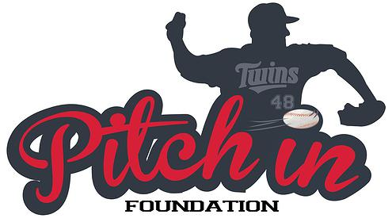

Email: pitchin48@yahoo.com Website: www.carlpavano.org

Carl Pavano, along with the Pitch In Foundation, will be hosting Pitch In For Santa Toy Drive. Come out to
Roger Dean Stadium, home of the Marlins Spring Training camp, on December 13th from 10am until 2pm.
The event will take place on the corner of Main St. and University Dr., on the plaza. In the event of rain, the
toy drive will be moved to Gate B of the stadium.

Billy The Marlin as well as current player Tom Koehler and former player Carl Pavano will be on site signing
autographs for those who bring a new unwrapped toy. The toys will be delivered directly to local Palm Beach
County elementary schools and given to parents struggling to make ends meet this holiday season. For those
unable to attend the event but interested in contributing, you may visit carlpavano.org to make a donation.

Pitch In Foundation was established in 2010 by the Pavano family, with the goal of providing hope to local
families and children in need. “It takes one foundation to create a movement but an army of people to make
it successful. Without the help of everyone we would not be able to impact as many families as we are setting
out to. Let’s come together and remind each other of the true meaning of giving during the holidays.”
-Carl Pavano. We would like to thank our sponsor, Off Lease Only, for their help driving this event
to success.

Pitch In Foundation has been part of many community awareness projects in the past. From back to school
drives, to making sure every child gets to experience a game in a major league ball park, to fishing excursions,
and most recently helping a town devastated by hurricane Sandy get its baseball back. Their hope is to
continue to make positive impacts on the surrounding communities and bring some smiles along the way.

